- Write a PHP script to keep track of number of times the web page has been access.
[Use session and cookies]

<html>
<head>
<title> Number of times the web page has been viited.</title>
</head>
<body>
<?php
session_start();
if(isset($_SESSION['count']))
$_SESSION['count']=$_SESSION['count']+1;
else
$_SESSION['count']=1;
echo "<h3>This page is accessed</h3>".$_SESSION['count'];
?>
Output:
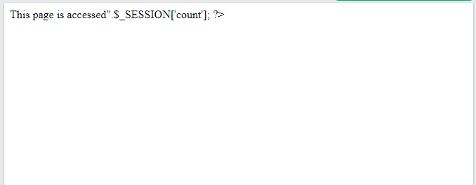

- Write a PHP script to change the preferences of your web page like font style, font size, font color,
background color using cookie. Display selected setting on next web page and actual implementation (with new settings) on third page.
1.html-
<html>
<body>
<form action="2.php" method="get">
<center>
<b>Select font style :</b><input type=text name=s1>
<b>Enter font size : </b><input type=text name=s>
<b>Enter font color :</b><input type=text name=c>
<b>Enter background color :</b><input type=text name=b>
<input type=submit value="Next">
</center>
</form>
</body>
</html>
2.php-
<?php
echo "style is ".$_GET['s1']."
color is ".$_GET['c']."
Background color is ".$_GET['b']."
size is ".$_GET['s'];
setcookie("set1",$_GET['s1'],time()+3600);
setcookie("set2",$_GET['c'],time()+3600);
setcookie("set3",$_GET['b'],time()+3600);
setcookie("set4",$_GET['s'],time()+3600);
?>
<a href="3.php">Show</a>
3.php-
<?php
$style=$_COOKIE['set1'];
$color=$_COOKIE['set2'];
$size=$_COOKIE['set4'];
$b_color=$_COOKIE['set3'];
$msg="Genus iT Solution";
echo "<body bgcolor=$b_color>";
echo "<font color=$color size=$size face=$style>$msg";
echo "</font></body>";
?>

Output:

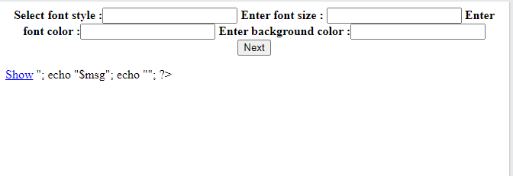

3..Write a javascript to display message ‘Exams are near, have you started preparing for?’ using alert, prompt and confirm boxes. Accept proper input from user and display messages accordingly.

<!DOCTYPE html>
<html>
<body>
<h1>Demo: alert()</h1>

<script>
alert("Exams are near, have you started preparing for?"); // display string message

</script>

<h1>Demo: confirm()</h1>
<p id="msg"></p>

<script>
var userPreference;

if (confirm("Do you want to save changes?") == true) {
userPreference = "Data saved successfully!";
} else {
userPreference = "Save Canceled!";
}

document.getElementById("msg").innerHTML = userPreference;

</script>

<h1>Demo: prompt()</h1>
<p id="msg"></p>

<script>
var tenure = prompt("Please enter preferred tenure in years", "15");

document.getElementById("msg").innerHTML = "You have entered " + tenure + " years";
</script>
</body>
</html>

Output:





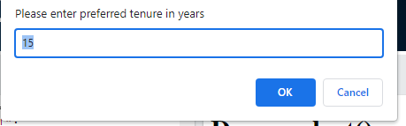

4..Write a PHP script to accept username and password. If in the first three chances, username and password entered is correct then display second form with “Welcome message” otherwise display error message. [Use Session]
<html>
<head>
<script>
function getans()
{
st1=document.getElementById('txtname').value;
st2=document.getElementById('txtpass').value;
ob=new XMLHttpRequest();
ob.onreadystatechange=function()
{
if(ob.readyState==4 && ob.status==200)
{
if(ob.responseText==3)
{
alert("sorry you lost the chances to login");
location="error.html";
}
else if(ob.responseText=="correct")
{
alert("you entered correct details");
}
else alert(ob.responseText);
}
}
ob.open("GET","slip8_Q2.php?n="+st1+"&p="+st2);
ob.send();
}
</script>
</head>
<body>
<input type=text id=txtname placeholder="username"></br>
<input type=password id=txtpass placeholder="password"></br>
<input type="button" onclick="getans()" value="Login">
</body>
</html>
HTML file : error.html
<html>
<body>
<h1>YOu lossed the chances of login</h1>
</body>
</html>
PHP file :
<?php
session_start();
$nm=$_GET['n'];
$ps=$_GET['p'];
if($nm==$ps)
{
echo "correct";
}
else if(isset($_SESSION['cnt']))
{
$x=$_SESSION['cnt'];
$x=$x+1;
$_SESSION['cnt']=$x;
echo $_SESSION['cnt'];
if($_SESSION['cnt']>=3)
$_SESSION['cnt']=1;
}
else
{
$_SESSION['cnt']=1;
echo "1";
}
?>

Output:

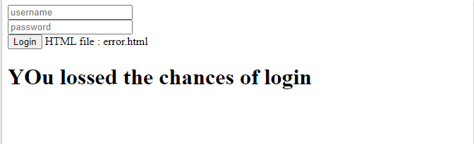

5..Add or append in paragraph text and also in the numbered(ordered) list in a given HTML document using jQuery selectors.
[Hint : Use Append( ) method]

<!DOCTYPE html>
<html>

<head>
<title>
jQuery append() Method
</title>

<script src="
https://ajax.googleapis.com/ajax/libs/jquery/3.3.1/jquery.min.js">
</script>

<!-- Script to append content -->
<script>
$(document).ready(function(){
$("#btn1").click(function(){
$("p").append(" <b>Append Geeks</b>.");
});

$("#btn2").click(function(){
$("ol").append("<li>Append Gfg</li>");
});
});
</script>
</head>

<body>
<h1 style="margin-left: 150px;">Geeks</h1>

<p>GeeksforGeeks</p>
<p>Jquery</p>

<ol>
<li>Gfg 1</li>
<li>Gfg 2</li>
<li>Gfg 3</li>
</ol>

<button id="btn1">Append Geeks</button>
<button id="btn2">Append Gfg</button>
</body>

</html>

Output:
